**Daily Scrum or Standup Meeting**

Team name: 5th Element

Scrum Master: Leonardo Craven

Date: November 16, 2021

| **Team Member** | **What did you do since the last scrum?** | **What do you plan to do before the next scrum?** | **What obstacles do you have?** |
| --- | --- | --- | --- |
| Leo | Updated class diagram, finished drink order notifications | Nothing | Midterms |
| Gavin | Finish order drinks page | Research placing templates within templates for navigation sidebar | None |
| Andrew | Worked on navigation sidebar, UI design | Finish navigation sidebar (done tonight) | None |
| Brock | Worked on company account migration | Work on company account migration (done tonight?) | Figure out how to create user in migration |

# Burndown

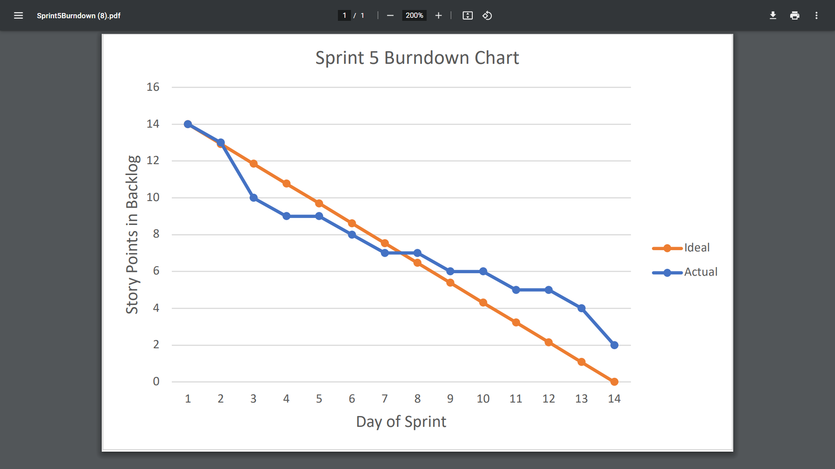

# Screenshot of you project board

